Task 11: Load Balancers & Auto Scaling Groups

Created Target Groups for ALB:

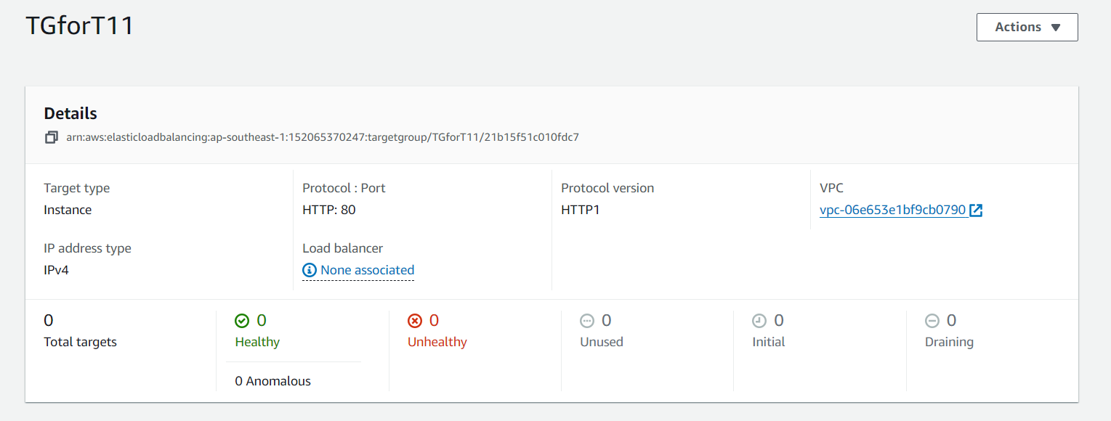

Launched Template:

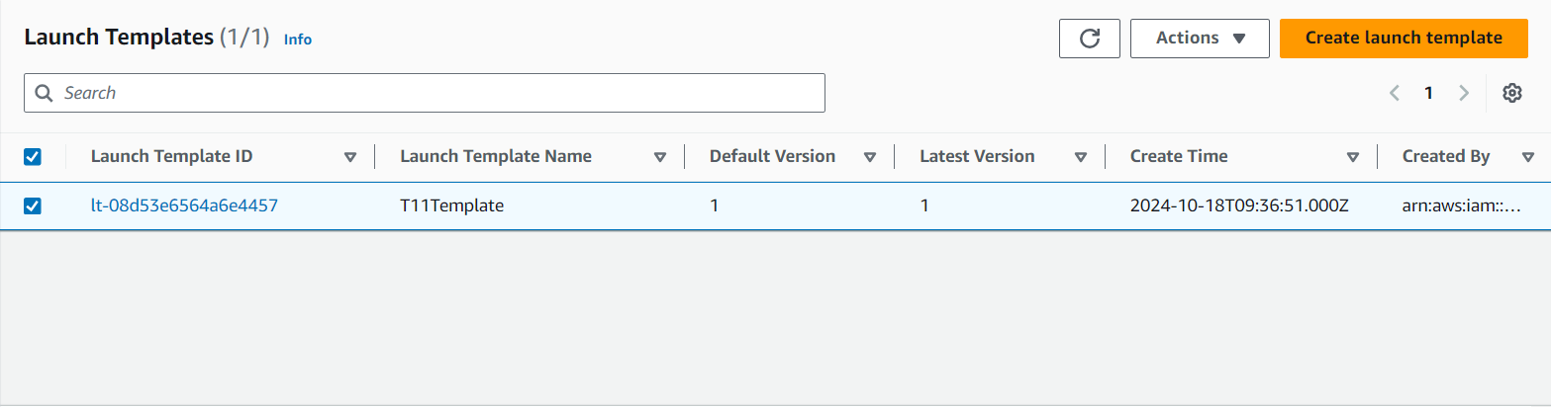

After Creating Auto Scaling Groups I have got 2 EC2 instances because I have provided minimum Desired capacity as 2 and maximum Desired capacity as 4

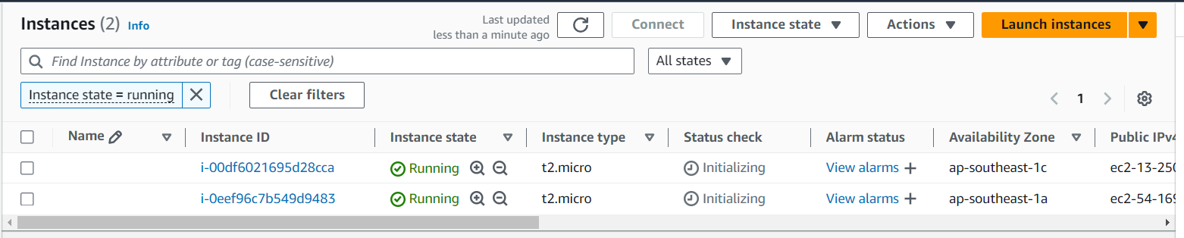

When I hit the DNS ARN I have got the below output:

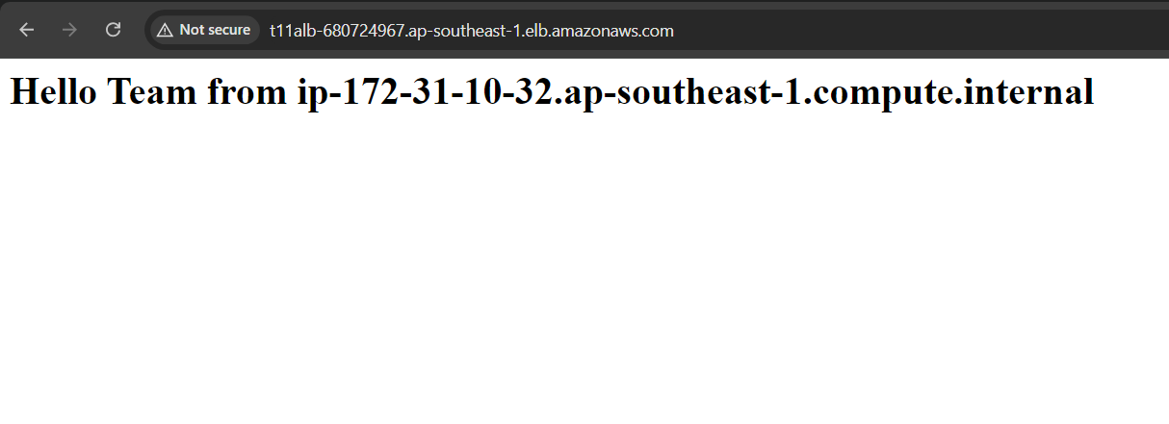

The script for getting the above output on our web:

**#!/bin/bashyum install httpd -ychkconfig httpd onservice httpd startecho "<h1> Hello Team from $(hostname -f)</h1>" > /var/www/html/index.html**